**Learning Sentiment-Specific Word Embedding (SSWE) for Twitter Sentiment Classification**

Chang Shu

cs530

**Introduction**

The paper I choose is Learning Sentiment-Specific Word Embedding (SSWE) for Twitter Sentiment Classification by Duyu Tang, Furu Wei, Nan Yang, Ming Zhou, Ting Liu and Bing Qin. The main problem they attempt to solve is to improve sentiment classification performance by generating better word embedding. Previously, model like C&W trains word embedding only based on syntactic information of text. This could be problematic since word embedding which doesn’t maintain sentiment information perform badly in sentiment classification task. Unlike C&W model which learns the language information (the original sentence should have larger probability than the corrupted sentence), the authors present a series of SSWE (Sentiment-Specific Word Embedding) models. First, SSWE_h, which predicts the sentiment polarity of the sentence. Not like C&W, SSWE_h is a supervised learning method which has ground truth of sentences’ polarity. Built-upon this, the authors propose SSWE_r, which is a simplified version of SSWE_h. The only change is SSWE_r removes the last softmax layer and change the sentiment distribution to sentiment score. The goal is to release the strict constrain of correct answer and make it an easier task to learn. Finally, the authors present SSWE_u, which is a combined version of SSWE_h and C&W.

**Model**

I implemented C&W, SSWE_h, SSWE_r and SSWE_u from the paper.

C&W model consists of four layers, namely lookup 🡪 linear 🡪 hTanh 🡪 linear (from bottom to top). Its training is based on the assumption that a text will have higher probability to be grammar error free than its corrupted version. A corrupted text is generated by replacing one word from the original text by a random word. The training object is to let the origin text to obtain a higher language model score than the corrupted text by a margin of 1. In fact, the language model score could be considered as a proxy of probability of a given sentence is grammar error free. Loss Function of C&W is: loss (t, tr) = max(0,1−fcw(t)+fcw(tr)) where t is the original ngram, tr is the corrupted ngram. And fcw is a one-dimensional scalar representing the language model score of input n gram. This function also indicates that the input of C&W model should be each pair of original text and corrupted text.

SSWE_h consists of five layers, namely lookup 🡪 linear 🡪 hTanh 🡪 linear 🡪 softmax (from bottom to top). Its training object is to predict sentiment polarity of the input text. The output is a vector which length is 2. One element is positive score, another one is negative score. It uses cross entropy as loss function. And for SSWE_r, which is a SSWE_h without softmax. After removing softmax, SSWE_h doesn’t set bound for positive & negative score. When positive score is larger than negative score, the text will be classified as positive, and vice versa. To keep align with this, it changes the loss function to make sure one score is larger than another score at least at a margin of 1. The loss function is written as

*lossr(t) = max(0, 1* *− δs(t)**f0r(t) + δs(t)**f1 (t)).*

*δs(*t) is an indicator reflecting the sentiment polarity ground truth of a sentence. When the sentiment is positive, δs(t) will be 1, while 0 for negative. f0r(t) is the predicted positive score.

SSWE_u is a combination of C&W and SSWE_r. It combines sentiment information and syntactic information by adding the two training objectives together. One training object is to make sure corrupted text have larger language model score then original text. This part of the model capture syntactic information. The second training object is to make sure the score difference between positive and negative sentiment score. Its loss function is written like this:

*lossu(t,tr) =α·**losscw(t,tr) +* *lossu(t,tr)* .

*losscw(t,tr) is exactly the same as the C&W model’s loss, and losscw(t,tr) is written as:*

*lossus(t, tr) = max(0, 1 − δs(t)f1u(t) + δs (t)**f1u (tr ))*

where *f1u(t)* stands for the sentiment score of original text. This part of loss is to ensure the sentiment score of original ngram should be more consistent with the ground truth than corrupted ngram.

Packages I used:

sklearn: <https://scikit-learn.org/stable/>

NLTK: <https://www.nltk.org/api/nltk.html>

Pytorch: <https://pytorch.org/>

**Dataset**

I didn’t use the dataset from the paper because it is not public available. The dataset I used comes from kaggle. This is the sentiment140 (<https://www.kaggle.com/kazanova/sentiment140>) dataset. It contains 1,600,000 tweets extracted using the twitter api. The tweets have been annotated. Each row contains the tweet id, user id, post time, tweet itself and the sentiment flag (0 or 1). After removing sentences that have less than 3 words, I have a training set with 1,214,748 samples and a validation set with 303,687 samples.

This is a completely different dataset compared with the dataset used in the original paper. Although they both collect tweets from Twitter, they could be different from each other in many ways, such as the tweets content, the way they define sentiment ground truth, or the data collected time. All the variation could impact word embedding training and the sentiment classification result.

**Data Preprocessing**

1. Preprocess pipeline: lower text -> remove punctuation -> tokenization -> stemming
2. For all experiments, I then remove sentences that have less than 3 words, as suggested by the paper. This results in the deletion of 14% of the original data
3. For training C&W, I using a sliding window of size 3 to create words snippets, each one of them will be one training sample
4. For training SSWE models, I use a sliding window of size 3 and step 3 for each sentence. Each sentence will be one training sample and the model’s output at each window will be averaged to get the sentence-wise prediction

**Model Training**

I train the model for 20 epochs with the initial learning rate of 1e-4. The learning rate is further reduced to 1e-5 after 10 epochs. I found this setup yields best performance.

Models are trained successfully but the results are not good enough. The plots below show that all the model converged within 20 epochs.



Figure 1 C&W Loss Figure 2 SSWE_h Loss (left) & macro-F1(right)



Figure 3 SSWE_r Loss & macro-F1 Figure 4 SSWE_u Loss & macro-F1

**Model Testing**

For the sentiment classification task, I took the previously trained models and generated the embeddings of each n-gram from the sentence. Followed by the paper, I concatenated the max, min and average of the embeddings to generate a 450-dimensions feature.

To evaluate the effectiveness of the learned embeddings, I do two-fold cross-validation on the validation set used training the SSWE models. For each fold, I train a logistic regression classifier on the train set and predict the probability of a sentence being positive on the validation set. I then evaluate the performance by the Macro F1-score. Macro-F1 is an average of class-wise F1 scores. It could be written as:

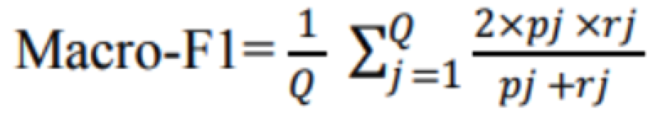

*Q is the total class for multi-class classification task.

While compared to the paper result which all the SSWE models achieved macro-F1s over 80 (SSWE_h 81.33, SSWE_r 80.45, SSWE_u 83.70) , my SSWE_h and SSWE_r achieves close to 78. For SSWE_u, the final output of SSWE_u is a vector of language model score and an unbounded sentiment score. Since the authors didn’t mentions how they set up the hard threshold for sentiment score, I am unable to calculate macro-F1 for SSWE_u. Instead, I calculated its AUC. And from the model ROC comparison below (Figure 5), it can be seen that models are underfitting.

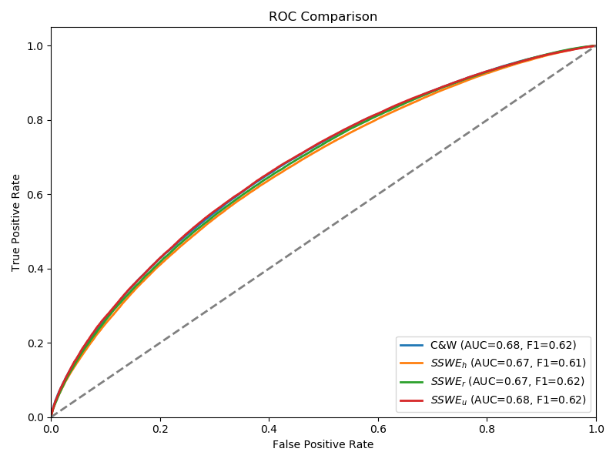

Figure 5 ROC comparison

One example where my model fails:

The sentiment score for “my result are so bad and not making any sense : (” is 0.62 which indicates its positive score is higher than negative score.

There are several possible reasons for the models’ underfitting. First, I was unable to find the Twitter NLP tokenization method as mentioned in the paper. As a complementary, a commonly used tokenization method which is based on NLTK, a python natural language processing library, is adopted in my implementation. This might result in suboptimal results since it is unable to deal with twitter slangs. Besides, I only utilized unigram to train models because of the limitation of time. Moreover, all the models are trained for 20 epochs. If time allows, more epochs could generate better result. Finally, as mentioned before, the dataset I used is totally different from the original dataset which could bring in variation in different ways.